NAME: M JEEVITHA
REG NO: 192424257
COURSE CODE: DSA0206 Computer Vision with Open CV

1(a). Read an Image and Convert it into Grayscale
Aim
To read an image using OpenCV and convert it into a grayscale image.
Procedure
- Import the OpenCV library.
- Read the input image using cv2.imread().
- Check whether the image is loaded successfully.
- Convert the image to grayscale using cv2.cvtColor().
- Display the original and grayscale images.
- Save the grayscale image.
Code:
# Import required libraries
import cv2
import matplotlib.pyplot as plt
# Read the image
image = cv2.imread("sample.jpg")
# Check whether image is loaded
if image is None:
print("Image not found!")
else:
# Convert BGR to RGB (for correct display)
rgb_image = cv2.cvtColor(image, cv2.COLOR_BGR2RGB)
# Convert RGB image to Grayscale
gray_image = cv2.cvtColor(rgb_image, cv2.COLOR_RGB2GRAY)
# Display Original Image
plt.subplot(1,2,1)
plt.imshow(rgb_image)
plt.title("Original Image")
plt.axis("off")
# Display Grayscale Image
plt.subplot(1,2,2)
plt.imshow(gray_image, cmap="gray")
plt.title("Grayscale Image")
plt.axis("off")
plt.show()

Output:
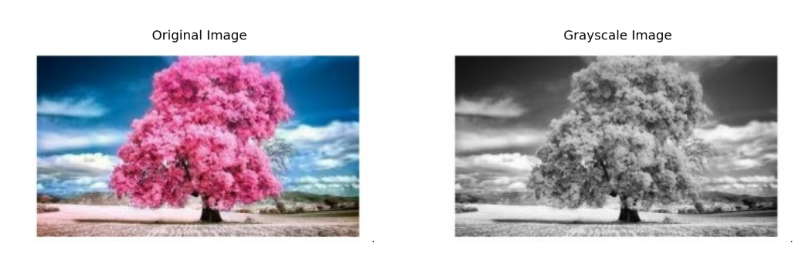
1(b). Read an Image and Convert it to Blur using GaussianBlur
Aim
To read an image and apply Gaussian Blur using OpenCV.
Procedure
- Import OpenCV.
- Read the image.
- Apply Gaussian Blur using cv2.GaussianBlur().
- Display the original and blurred images.
- Save the blurred image.
Code:
import cv2

# Step 1: Read the image
image = cv2.imread("sample.jpg")

# Step 2: Check whether the image is loaded
if image is None:
print("Error: Image not found!")
else:
# Step 3: Apply Gaussian Blur
blurred_image = cv2.GaussianBlur(image, (15, 15), 0)

# Step 4: Display the original image
cv2.imshow("Original Image", image)

# Step 5: Display the blurred image
cv2.imshow("Gaussian Blurred Image", blurred_image)

# Step 6: Save the blurred image (optional)
cv2.imwrite("blurred_image.jpg", blurred_image)

# Step 7: Wait until a key is pressed
cv2.waitKey(0)

# Step 8: Close all windows
cv2.destroyAllWindows()
Output:
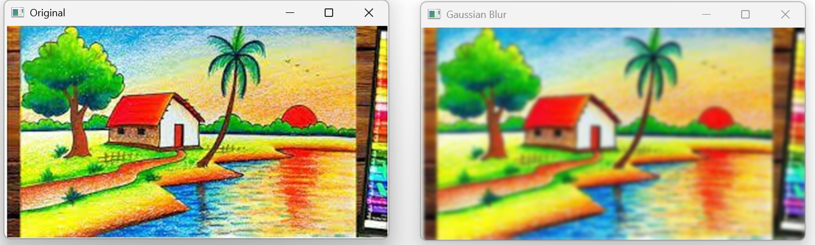
1(c). Read an Image and Show Outline using Canny Function
Aim
To detect the edges (outlines) of an image using the Canny Edge Detection algorithm.
Procedure
- Import OpenCV.
- Read the image.
- Convert the image to grayscale.
- Apply cv2.Canny() for edge detection.
- Display the original and edge-detected images.
- Save the output image.
Code:
import cv2
import numpy as np
# Step 1: Read the image
image = cv2.imread("sample.jpg")
# Step 2: Check whether the image is loaded
if image is None:
print("Error: Image not found!")
else:
# Step 3: Convert the image to grayscale
gray = cv2.cvtColor(image, cv2.COLOR_BGR2GRAY)
# Step 4: Apply Canny Edge Detection
edges = cv2.Canny(gray, 100, 200)
# Step 5: Display the original image
cv2.imshow("Original Image", image)
# Step 6: Display the outlined image
cv2.imshow("Canny Edge Image", edges)
# Step 7: Save the output image
cv2.imwrite("canny_output.jpg", edges)
# Step 8: Wait for a key press
cv2.waitKey(0)
# Step 9: Close all windows
cv2.destroyAllWindows()
Output:
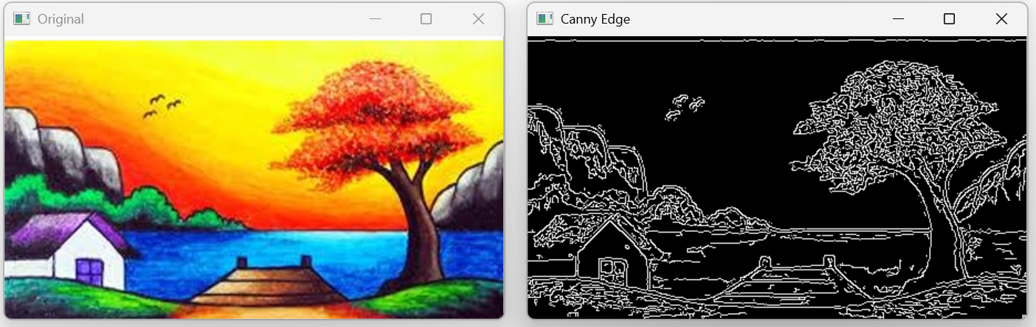
1(d). Read an Image and Dilate it using Dilate Function
Aim
To read an image and enlarge bright regions using the dilation operation.
Procedure
- Import OpenCV and NumPy.
- Read the image.
- Create a kernel using np.ones().
- Apply dilation using cv2.dilate().
- Display the original and dilated images.
- Save the output image.
Code:
import cv2
import numpy as np
# Step 1: Read the image
image = cv2.imread("sample.jpg")
# Step 2: Check whether the image is loaded
if image is None:
print("Error: Image not found!")
else:
# Step 3: Create a kernel (3x3 matrix)
kernel = np.ones((3, 3), np.uint8)
# Step 4: Apply Dilation
dilated_image = cv2.dilate(image, kernel, iterations=1)
# Step 5: Display the original image
cv2.imshow("Original Image", image)
# Step 6: Display the dilated image
cv2.imshow("Dilated Image", dilated_image)
# Step 7: Save the output image (optional)
cv2.imwrite("dilated_image.jpg", dilated_image)
# Step 8: Wait for a key press
cv2.waitKey(0)
# Step 9: Close all windows
cv2.destroyAllWindows()
Output:
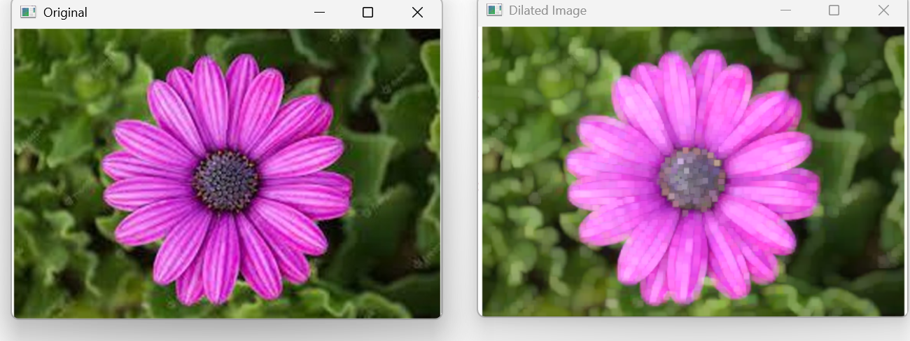
1(e). Read an Image and Erode it using Erode Function
Aim
To read an image and shrink bright regions using the erosion operation.
Procedure
- Import OpenCV and NumPy.
- Read the image.
- Create a kernel.
- Apply erosion using cv2.erode().
- Display the original and eroded images.
- Save the output image.
Code:
import cv2
import numpy as np
# Step 1: Read the image
image = cv2.imread("sample.jpg")
# Step 2: Check whether the image is loaded
if image is None:
print("Error: Image not found!")
else:
# Step 3: Create a 3x3 kernel
kernel = np.ones((3, 3), np.uint8)

# Step 4: Apply erosion
eroded_image = cv2.erode(image, kernel, iterations=1)
# Step 5: Display the original image
cv2.imshow("Original Image", image)
# Step 6: Display the eroded image
cv2.imshow("Eroded Image", eroded_image)
# Step 7: Save the eroded image (optional)
cv2.imwrite("eroded_image.jpg", eroded_image)
# Step 8: Wait until a key is pressed
cv2.waitKey(0)
# Step 9: Close all windows
cv2.destroyAllWindows()
Output:
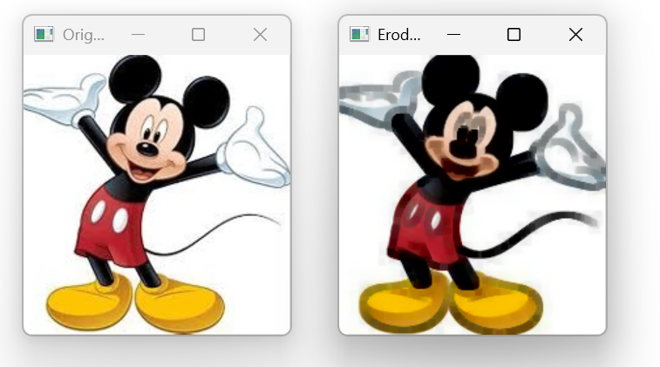

2. Perform basic video processing operations on the captured video
Aim
To read a captured video in Python using OpenCV and display it in slow motion and fast motion.
Procedure
Import the required libraries (cv2 and time).
Read the video using cv2.VideoCapture().
Read each frame of the video.
Display the video using cv2.imshow().
Use time.sleep() to play the video in slow motion.
Press Esc to stop the video.
Release the video and close all windows.
Code
import cv2
import time
cap = cv2.VideoCapture("video.mp4")
while True:
ret, frame = cap.read()
if not ret:
break
cv2.imshow("Video", frame)
time.sleep(0.1)
if cv2.waitKey(1) & 0xFF == 27:
break
cap.release()
cv2.destroyAllWindows()
OUTPUT:
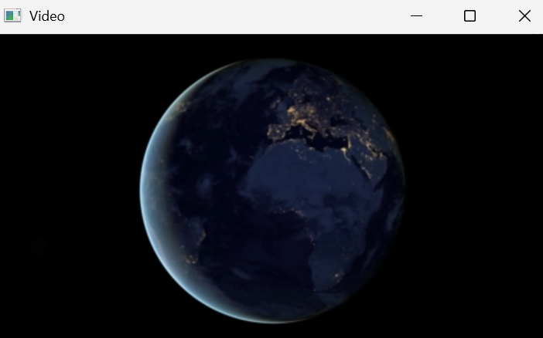

Experiment 3: Capture Video from Webcam
Aim
To capture video from a webcam and display it in slow motion and fast motion using OpenCV.
Procedure
Import the required libraries.
Access the webcam using cv2.VideoCapture(0).
Capture frames continuously.
Display the webcam video.
Use time.sleep() for slow motion.
Press Esc to stop.
Release the webcam and close all windows.
Code
import cv2
import time
cap = cv2.VideoCapture(0)
while True:
ret, frame = cap.read()
if not ret:
break
cv2.imshow("Webcam", frame)
time.sleep(0.1)
if cv2.waitKey(1) & 0xFF == 27:
break
cap.release()
cv2.destroyAllWindows()
OUTPUT:
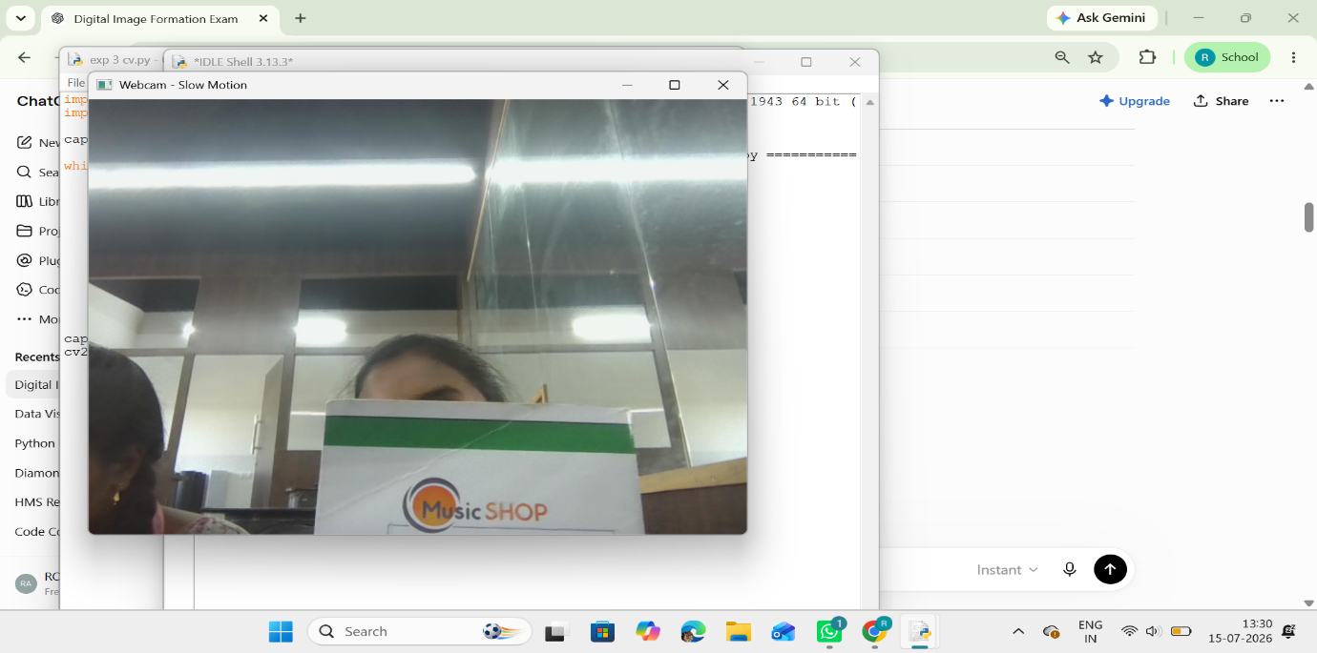
Experiment 4: Scaling an Image
Aim
To scale an image to bigger and smaller sizes using OpenCV.
Procedure
Import the OpenCV library.
Read the input image.
Resize the image to a smaller size.
Resize the image to a bigger size.
Display the original, smaller, and bigger images.
Close all windows.
Code:
import cv2
img = cv2.imread("grayscale.jpg")
small = cv2.resize(img, None, fx=0.5, fy=0.5)
big = cv2.resize(img, None, fx=2, fy=2)
cv2.imshow("Original Image", img)
cv2.imshow("Smaller Image", small)
cv2.imshow("Bigger Image", big)

cv2.waitKey(0)
cv2.destroyAllWindows()
OUTPUT:
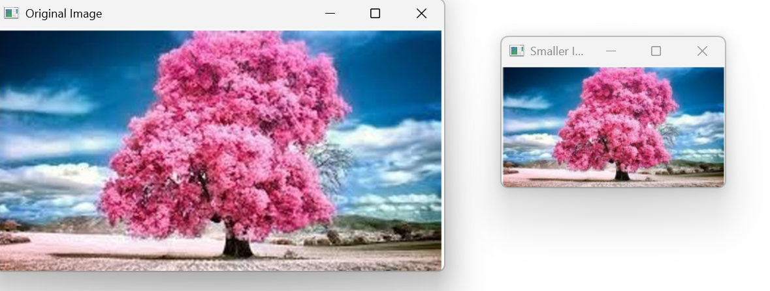
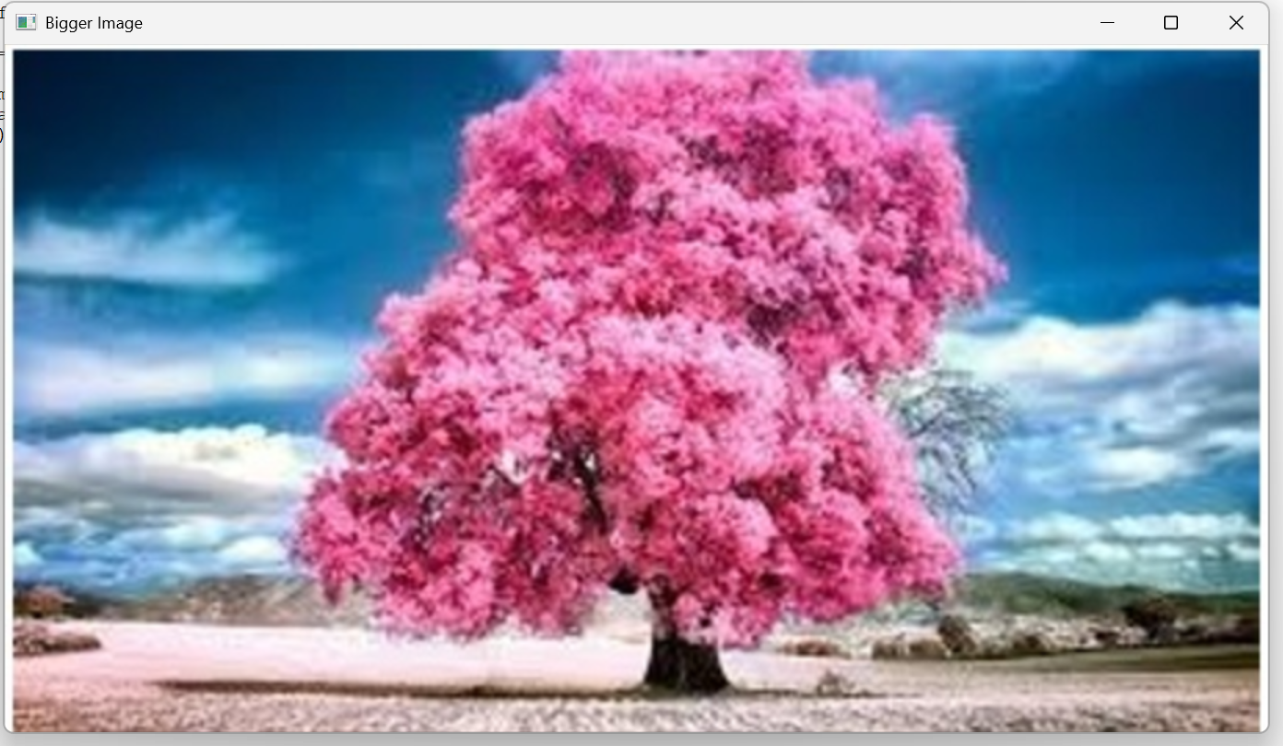
Experiment 5: Rotation of an Image
Aim
To rotate an image in clockwise and counter-clockwise directions using OpenCV.
Procedure
Import the OpenCV library.
Read the input image.
Rotate the image clockwise.
Rotate the image counter-clockwise.
Display the original and rotated images.
Close all windows.
Code
import cv2
img = cv2.imread("grayscale.jpg")
clockwise = cv2.rotate(img, cv2.ROTATE_90_CLOCKWISE)
counterclockwise = cv2.rotate(img, cv2.ROTATE_90_COUNTERCLOCKWISE)
cv2.imshow("Original Image", img)
cv2.imshow("Clockwise Rotation", clockwise)
cv2.imshow("Counter Clockwise Rotation", counterclockwise)
cv2.waitKey(0)
cv2.destroyAllWindows()
OUTPUT:
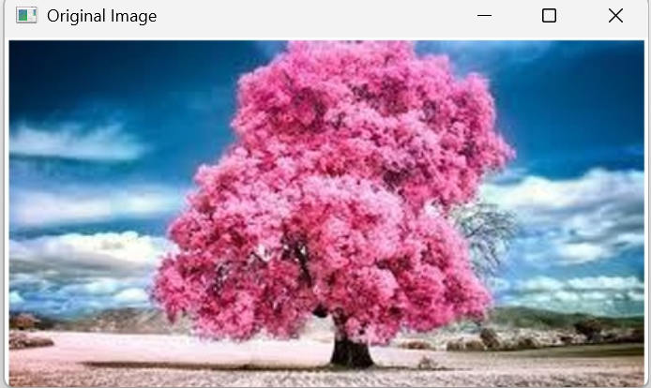
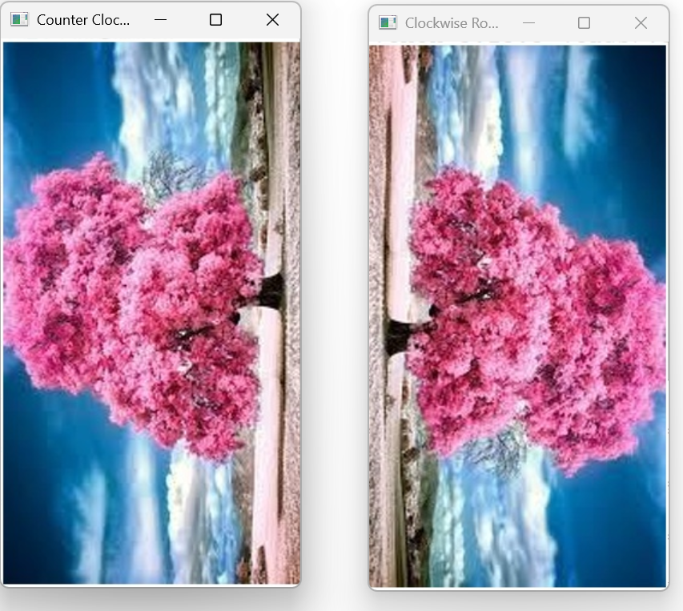
Experiment 6: Moving (Translation) of an Image
Aim
To move (translate) an image from one position to another using OpenCV.
Procedure
Import the required libraries.
Read the input image.
Create a translation matrix.
Apply the translation using cv2.warpAffine().
Display the original and translated images.
Close all windows.
CODE:
import cv2
import numpy as np
img = cv2.imread("grayscale.jpg")
rows, cols = img.shape[:2]
M = np.float32([[1, 0, 100], [0, 1, 50]])
translated = cv2.warpAffine(img, M, (cols, rows))
cv2.imshow("Original Image", img)
cv2.imshow("Translated Image", translated)
cv2.waitKey(0)
cv2.destroyAllWindows()
OUTPUT:
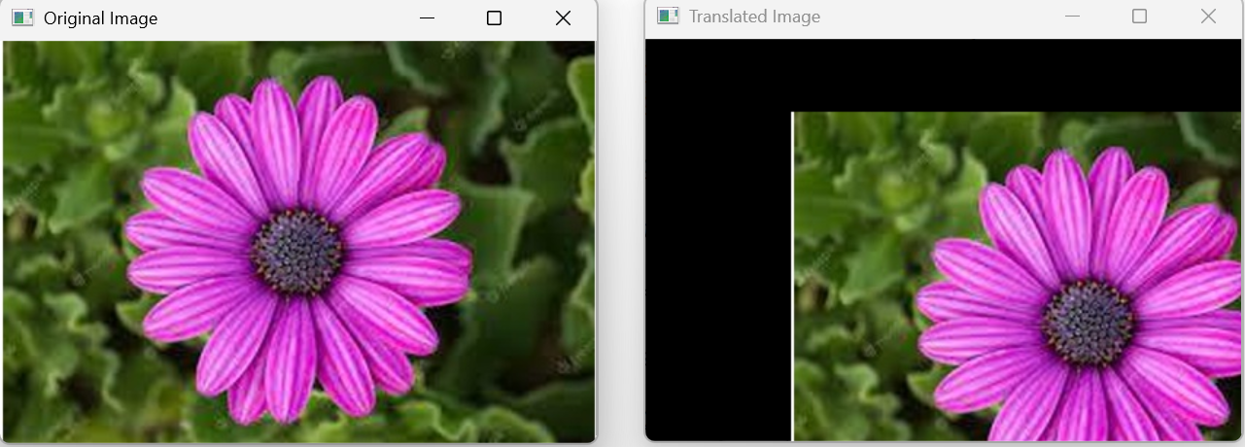

Experiment 7: Affine Transformation
Aim
To perform affine transformation on an image using OpenCV.
Procedure
1. Import the required libraries.
2. Read the input image.
3. Select three source and destination points.
4. Calculate the affine transformation matrix.
5. Apply the transformation.
6. Display the output image.
Code
import cv2
import numpy as np
img = cv2.imread("grayscale.jpg")
rows, cols = img.shape[:2]
pts1 = np.float32([[50,50],[200,50],[50,200]])
pts2 = np.float32([[10,100],[200,50],[100,250]])
M = cv2.getAffineTransform(pts1, pts2)
result = cv2.warpAffine(img, M, (cols, rows))
cv2.imshow("Original Image", img)
cv2.imshow("Affine Transformation", result)
cv2.waitKey(0)
cv2.destroyAllWindows()
OUTPUT:
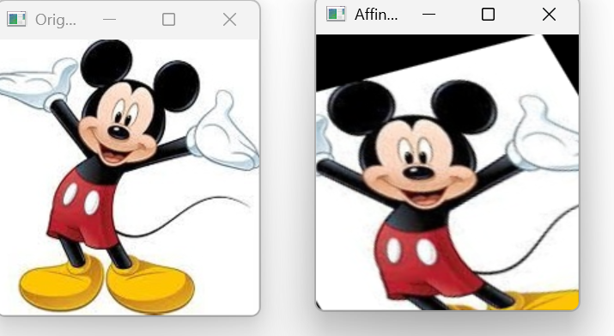

Experiment 8: Perspective Transformation on an Image
Aim
To perform perspective transformation on an image using OpenCV.
Procedure
1. Import the required libraries.
2. Read the image.
3. Select four source and destination points.
4. Compute the perspective transformation matrix.
5. Apply the transformation.
6. Display the output.
Code
import cv2
import numpy as np
img = cv2.imread("grayscale.jpg")
rows, cols = img.shape[:2]
pts1 = np.float32([[50,50],[250,50],[50,250],[250,250]])
pts2 = np.float32([[10,100],[200,50],[100,250],[250,250]])
M = cv2.getPerspectiveTransform(pts1, pts2)
result = cv2.warpPerspective(img, M, (cols, rows))
cv2.imshow("Original Image", img)
cv2.imshow("Perspective Transformation", result)
cv2.waitKey(0)
cv2.destroyAllWindows()
OUTPUT:
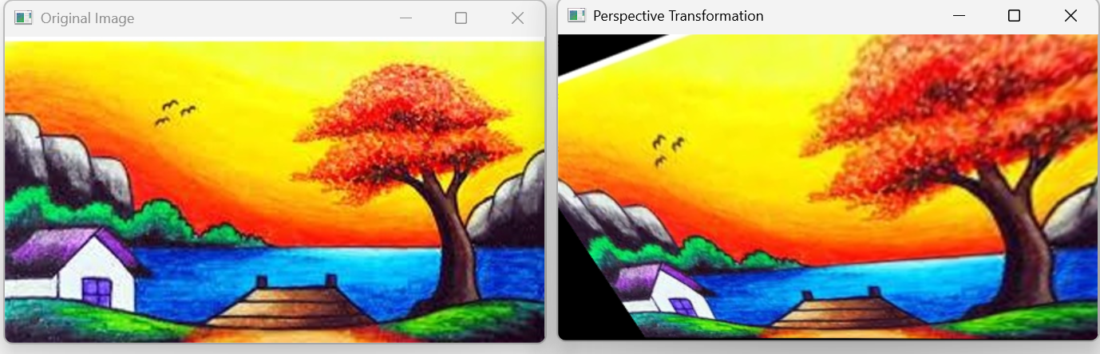
Experiment 9: Perspective Transformation on Video
Aim
To perform perspective transformation on a video using OpenCV.
Procedure
1. Import the required libraries.
2. Read the input video.
3. Read each frame.
4. Compute the perspective transformation matrix.
5. Apply the transformation to every frame.
6. Display the transformed video.
7. Press **Esc** to exit.
Code
import cv2
import numpy as np
cap = cv2.VideoCapture("video.mp4")
while True:
ret, frame = cap.read()
if not ret:
break
rows, cols = frame.shape[:2]
pts1 = np.float32([[50,50],[250,50],[50,250],[250,250]])
pts2 = np.float32([[10,100],[200,50],[100,250],[250,250]])
M = cv2.getPerspectiveTransform(pts1, pts2)
result = cv2.warpPerspective(frame, M, (cols, rows))
cv2.imshow("Perspective Video", result)
if cv2.waitKey(1) & 0xFF == 27:
break
cap.release()
cv2.destroyAllWindows()
OUTPUT:
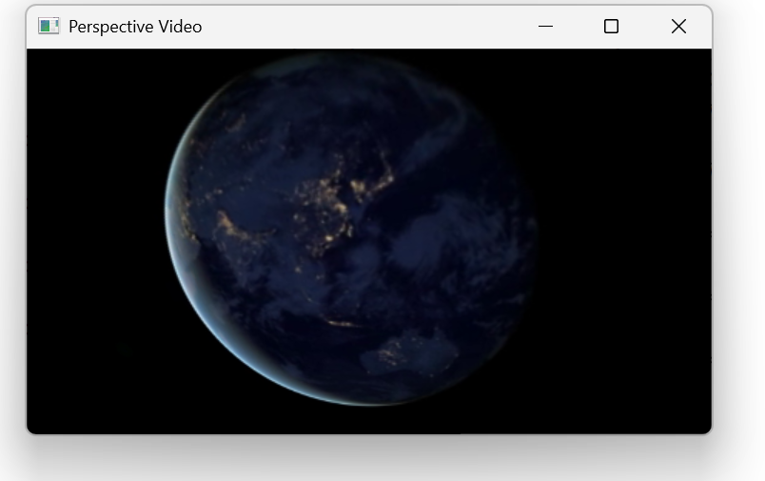
Experiment 10: Homography Matrix Transformation
Aim
To perform image transformation using a homography matrix.
Procedure
1. Import the required libraries.
2. Read the input image.
3. Define four corresponding points.
4. Find the homography matrix.
5. Apply the transformation.
6. Display the transformed image.
Code
import cv2
import numpy as np
img = cv2.imread("grayscale.jpg")
rows, cols = img.shape[:2]
src = np.float32([[50,50],[250,50],[50,250],[250,250]])
dst = np.float32([[10,100],[200,50],[100,250],[250,250]])
H, status = cv2.findHomography(src, dst)
result = cv2.warpPerspective(img, H, (cols, rows))
cv2.imshow("Original Image", img)
cv2.imshow("Homography Transformation", result)
cv2.waitKey(0)
cv2.destroyAllWindows()
OUTPUT:
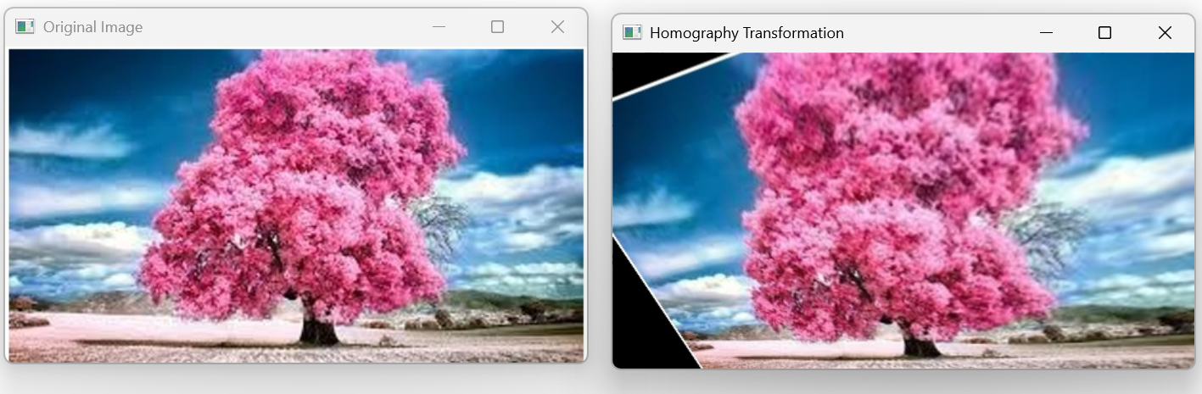

Experiment 11: Direct Linear Transformation (DLT)
Aim
To perform image transformation using the Direct Linear Transformation (DLT) method in OpenCV.
Procedure
1. Import the required libraries.
2. Read the input image.
3. Define four source points and four destination points.
4. Compute the transformation matrix.
5. Apply the transformation using `cv2.warpPerspective()`.
6. Display the transformed image.
Code
import cv2
import numpy as np
img = cv2.imread("grayscale.jpg")
rows, cols = img.shape[:2]
src = np.float32([[50,50],[250,50],[50,250],[250,250]])
dst = np.float32([[10,100],[220,50],[80,250],[250,250]])
M = cv2.getPerspectiveTransform(src, dst)
result = cv2.warpPerspective(img, M, (cols, rows))
cv2.imshow("Original Image", img)
cv2.imshow("DLT Transformation", result)
cv2.waitKey(0)
cv2.destroyAllWindows()
OUTPUT
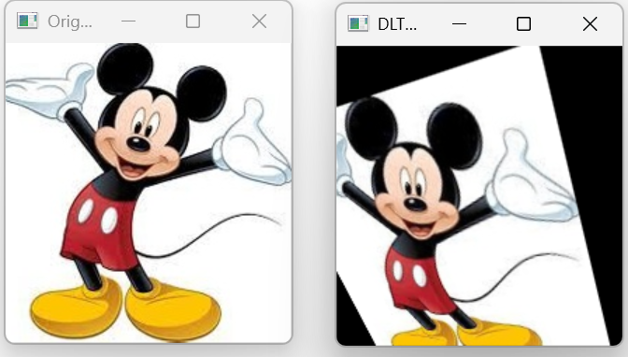
Experiment 12: Edge Detection using Canny Method
Aim
To detect the edges of an image using the Canny edge detection method.
Procedure
1. Import the OpenCV library.
2. Read the input image.
3. Convert the image to grayscale.
4. Apply the Canny edge detection algorithm.
5. Display the original and edge-detected images.
Code
import cv2
img = cv2.imread("grayscale.jpg")
gray = cv2.cvtColor(img, cv2.COLOR_BGR2GRAY)
edges = cv2.Canny(gray,100,200)
cv2.imshow("Original Image",img)
cv2.imshow("Canny Edge Detection",edges)
cv2.waitKey(0)
cv2.destroyAllWindows()
OUTPUT
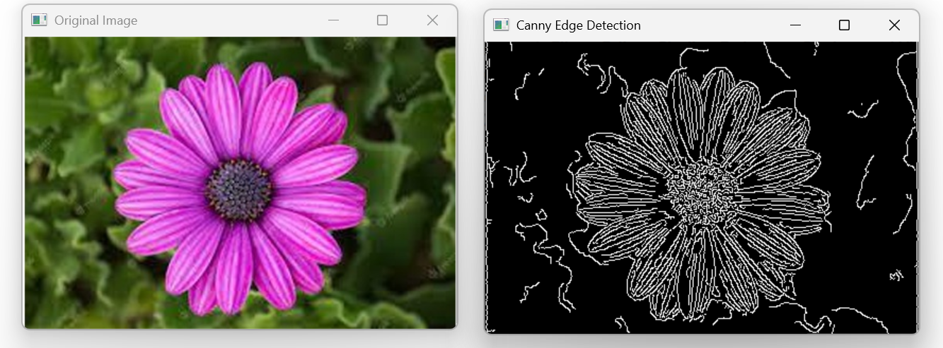
Experiment 13: Edge Detection using Sobel Matrix along X-axis
Aim
To detect image edges along the X-axis using the Sobel operator.
Procedure
1. Import the OpenCV library.
2. Read the image.
3. Convert it to grayscale.
4. Apply the Sobel operator along the X-axis.
5. Display the output.
Code
import cv2
img = cv2.imread("grayscale.jpg")
gray = cv2.cvtColor(img,cv2.COLOR_BGR2GRAY)
sobelx = cv2.Sobel(gray,cv2.CV_64F,1,0,ksize=3)
cv2.imshow("Original Image",img)
cv2.imshow("Sobel X",sobelx)
cv2.waitKey(0)
cv2.destroyAllWindows()
OUTPUT
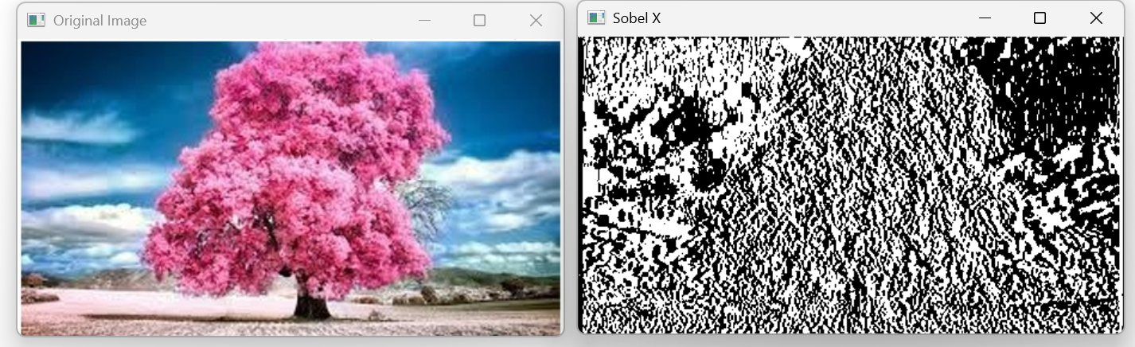
Experiment 14: Edge Detection using Sobel Matrix along Y-axis
Aim
To detect image edges along the Y-axis using the Sobel operator.
Procedure
1. Import the OpenCV library.
2. Read the image.
3. Convert it to grayscale.
4. Apply the Sobel operator along the Y-axis.
5. Display the output.
Code
import cv2
img = cv2.imread("grayscale.jpg")
gray = cv2.cvtColor(img,cv2.COLOR_BGR2GRAY)
sobely = cv2.Sobel(gray,cv2.CV_64F,0,1,ksize=3)
cv2.imshow("Original Image",img)
cv2.imshow("Sobel Y",sobely)
cv2.waitKey(0)
cv2.destroyAllWindows()
OUTPUT
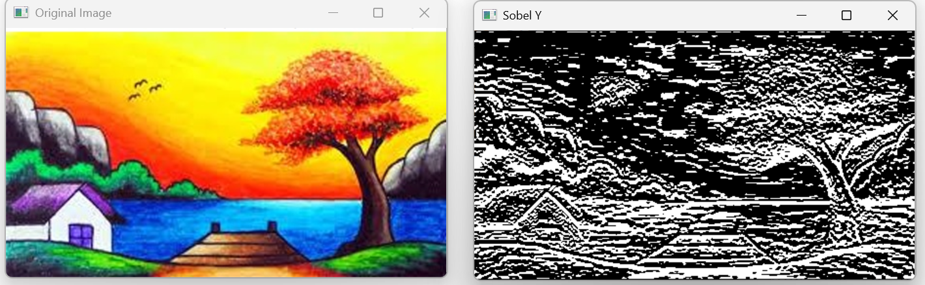
Experiment 15: Edge Detection using Sobel Matrix along X and Y Axes
Aim
To detect image edges using the Sobel operator along both X and Y axes.
Procedure
1. Import the OpenCV library.
2. Read the image.
3. Convert it to grayscale.
4. Apply the Sobel operator along both X and Y axes.
5. Combine the two results.
6. Display the output.
Code
import cv2
img = cv2.imread("grayscale.jpg")
gray = cv2.cvtColor(img,cv2.COLOR_BGR2GRAY)
sobelx = cv2.Sobel(gray,cv2.CV_64F,1,0,ksize=3)
sobely = cv2.Sobel(gray,cv2.CV_64F,0,1,ksize=3)
sobelxy = cv2.addWeighted(sobelx,0.5,sobely,0.5,0)
cv2.imshow("Original Image",img)
cv2.imshow("Sobel XY",sobelxy)
cv2.waitKey(0)
cv2.destroyAllWindows()
OUTPUT
